**Class and Quiz Snapshots:**

**Java and J2EE( 9 to 1.30)**

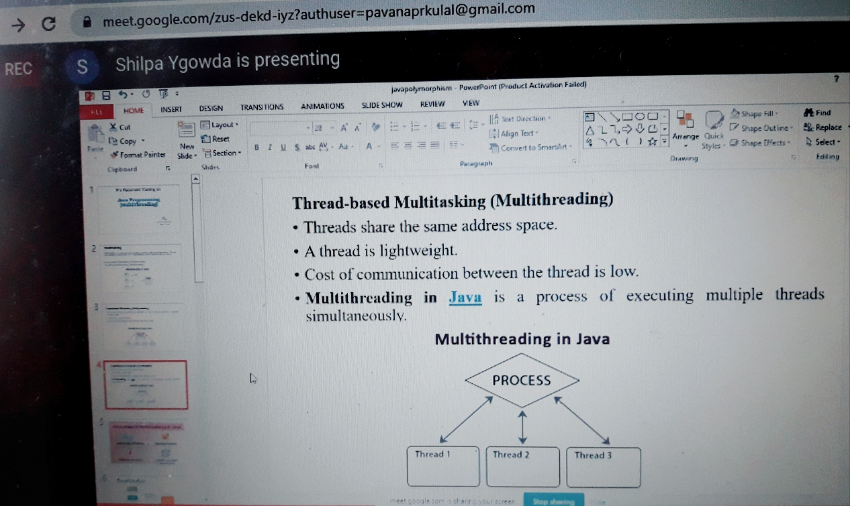

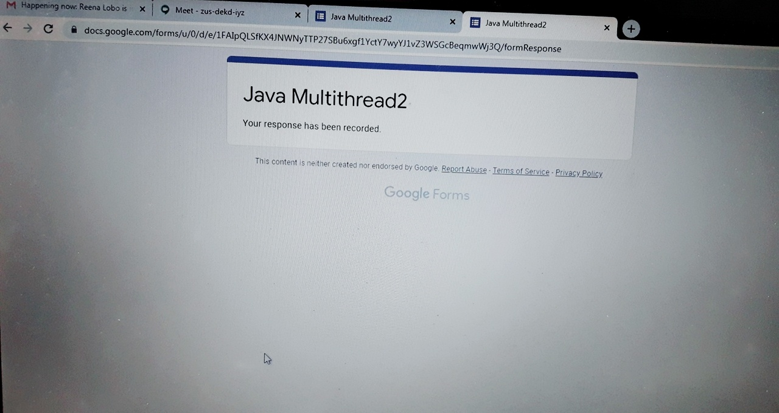

**Data Structures (from 11.30 to 1.00)**

